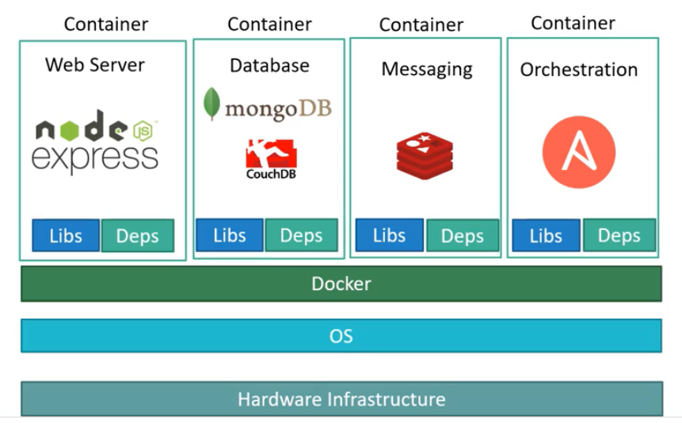

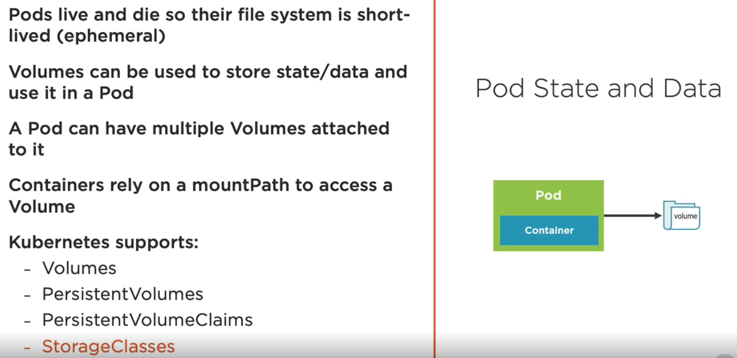

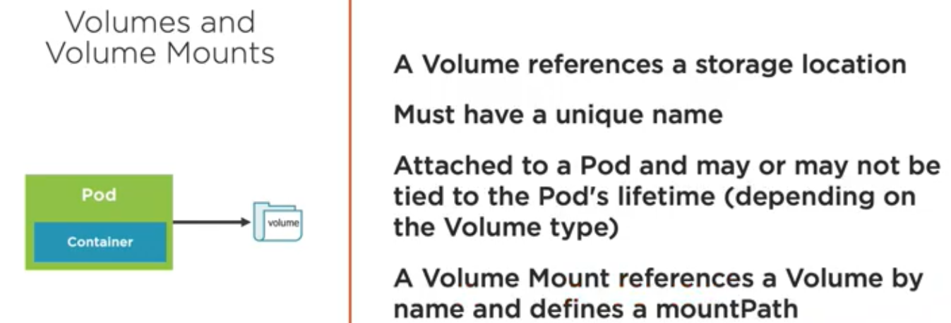

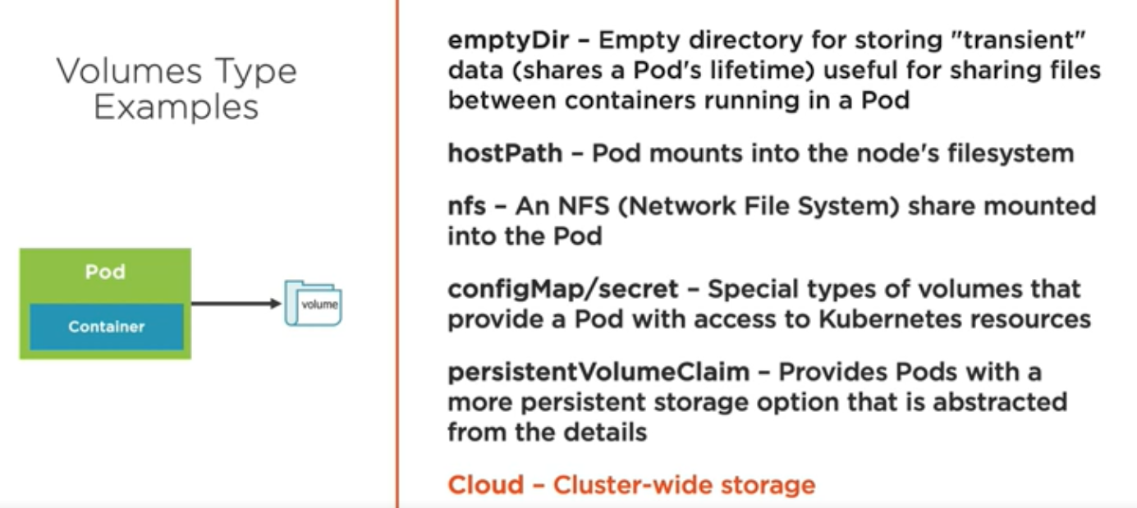

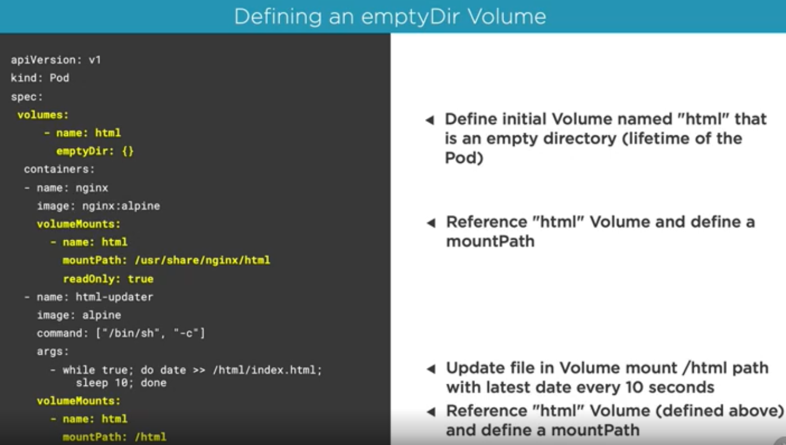

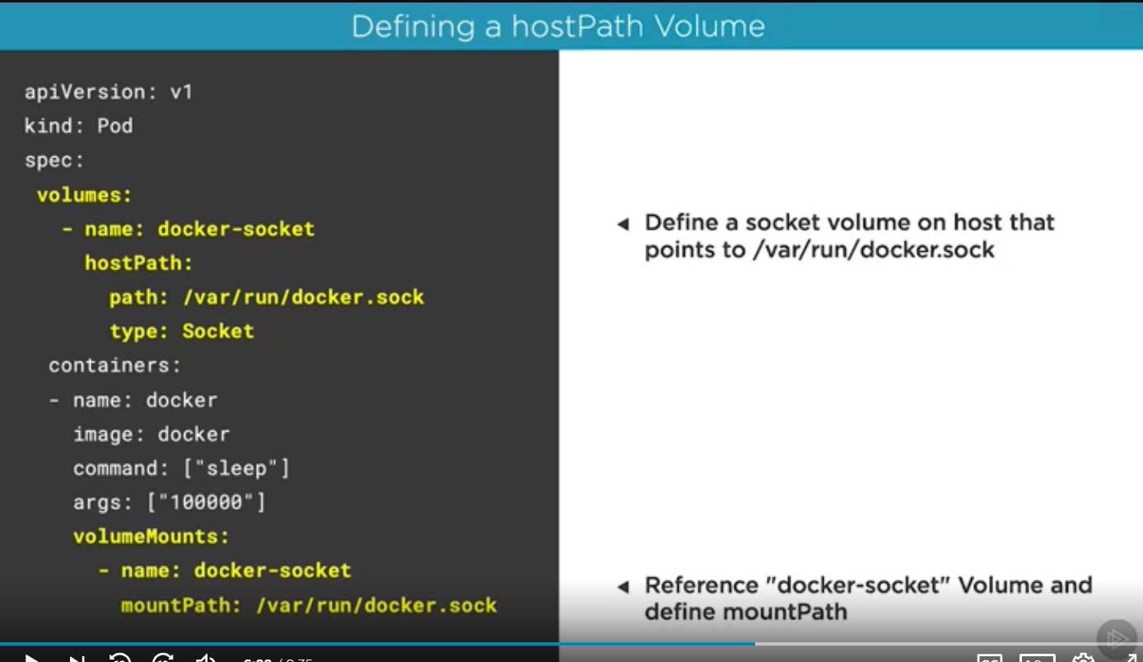

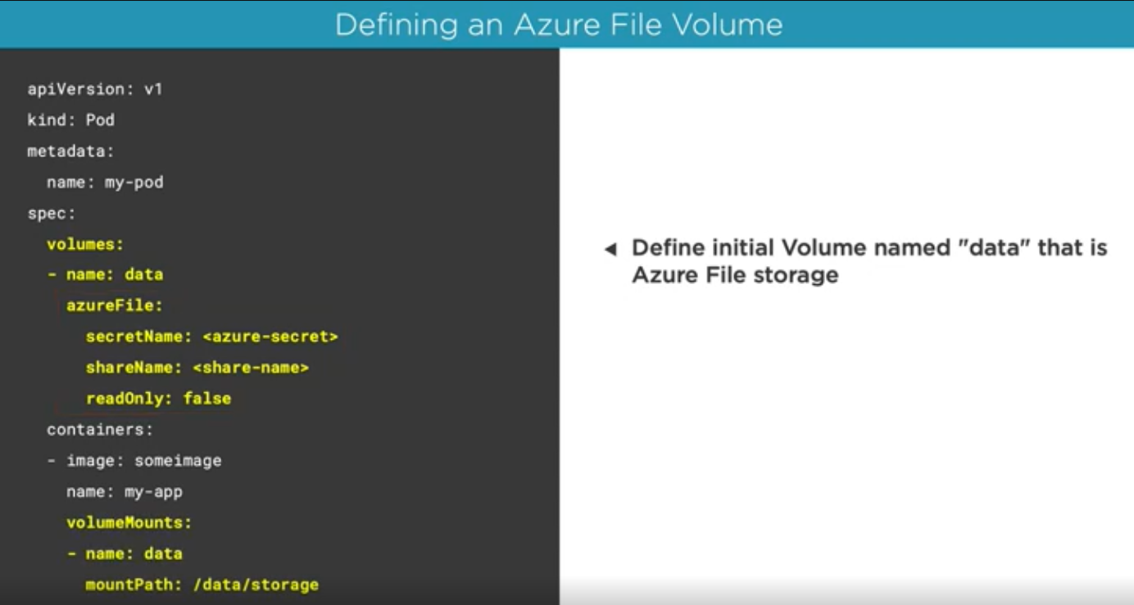

<https://theithollow.com/2019/03/04/kubernetes-persistent-volumes/>

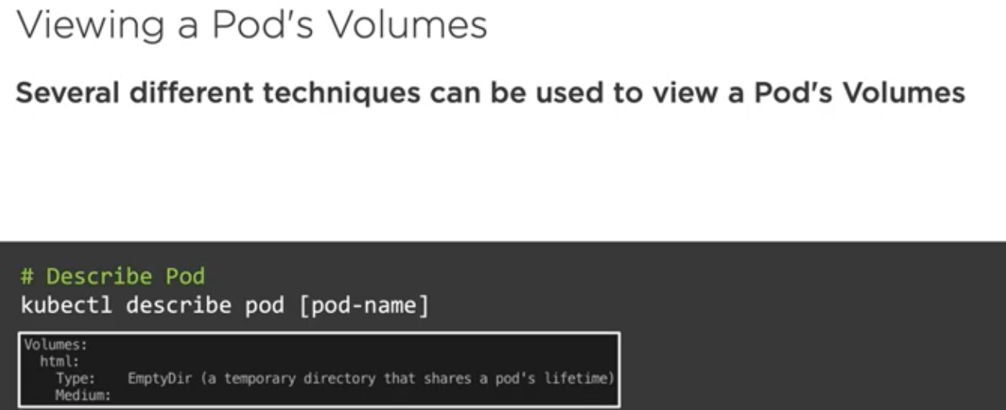

When there is multiple container inside a pod, it gets easier to communicate between them using empty directory volume.

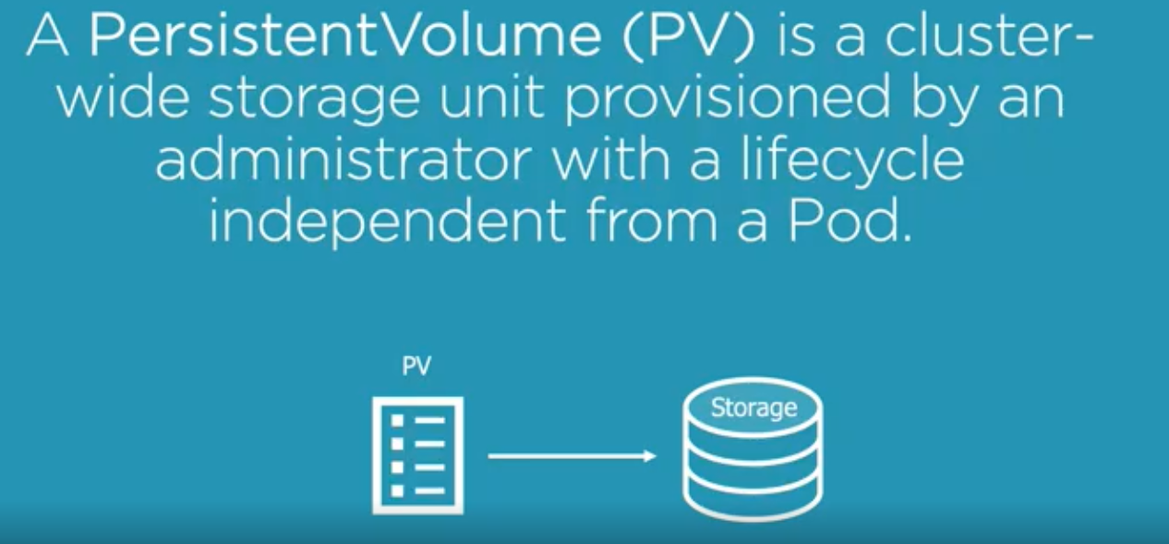

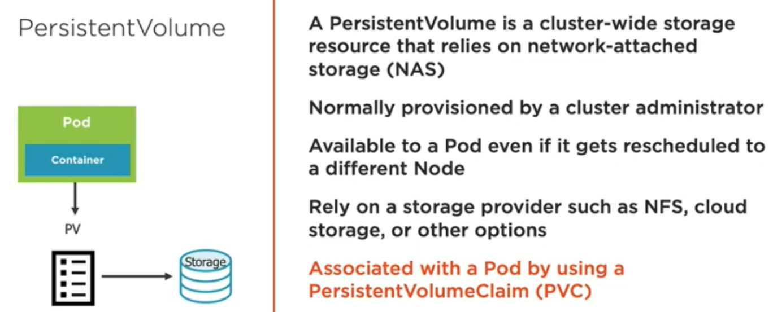

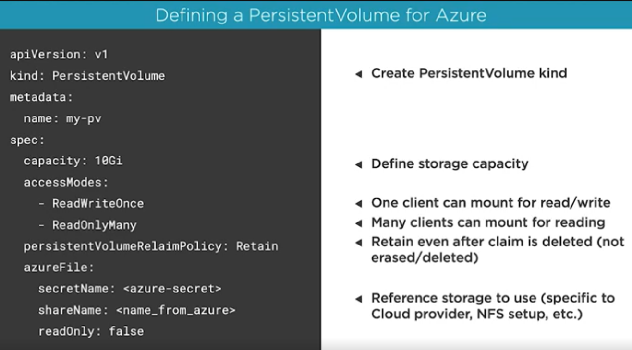

**Storage Class:**

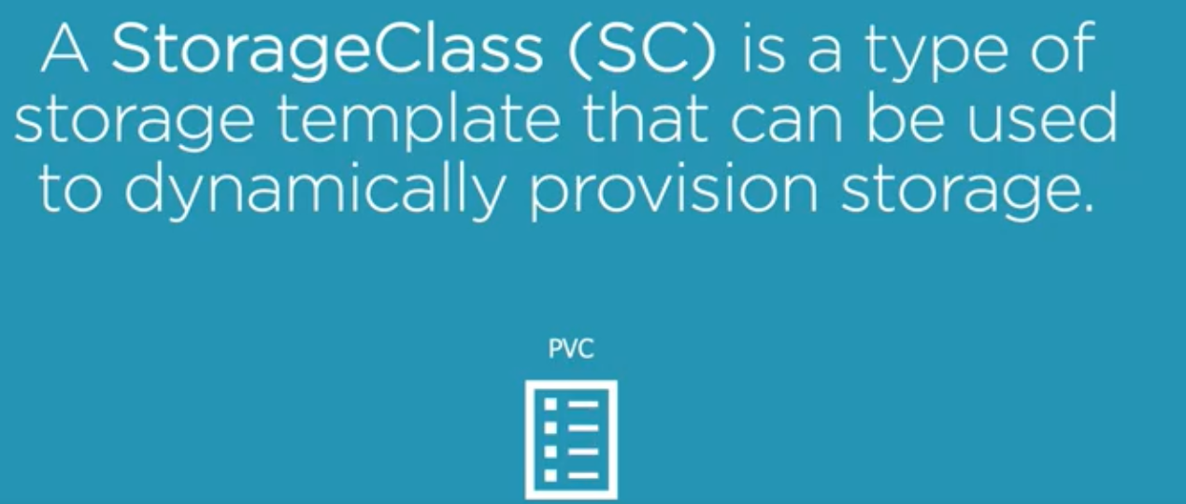

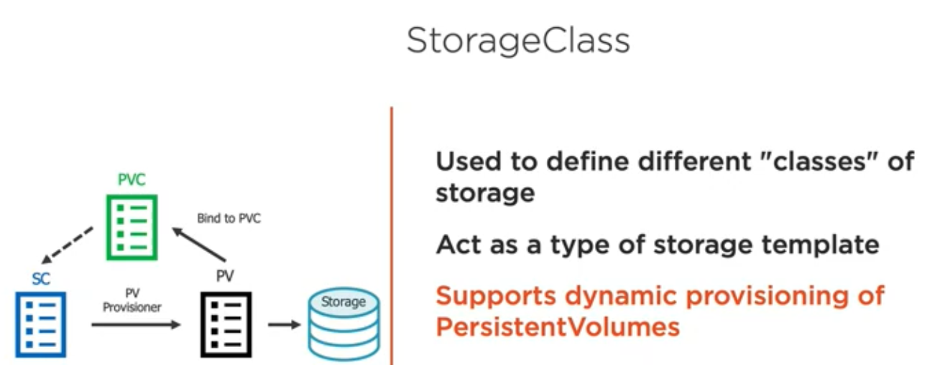

**Storage Class Workflow:**

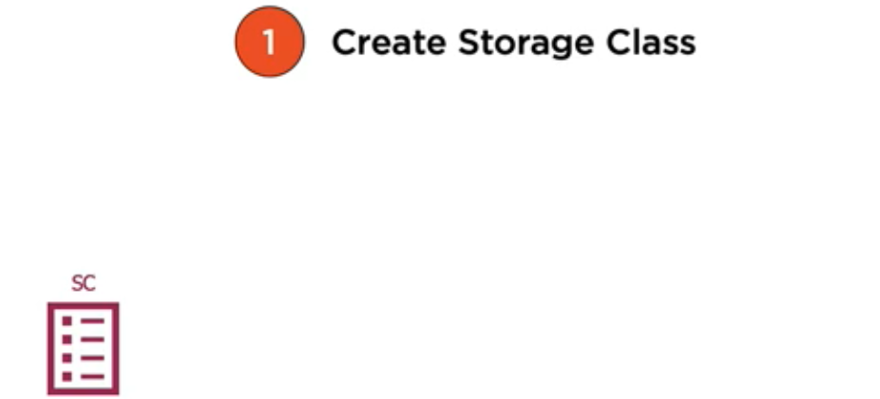

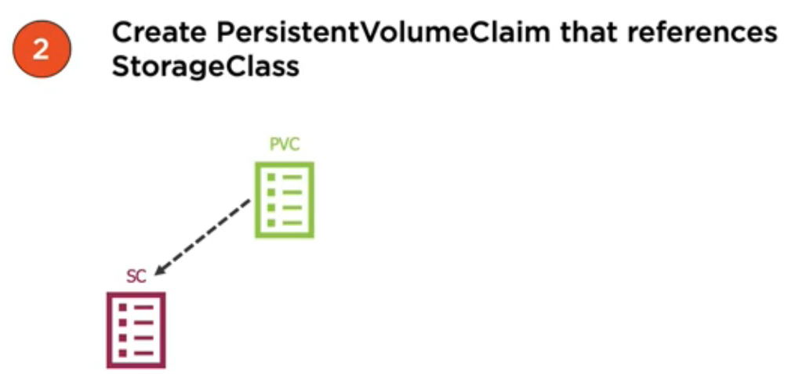

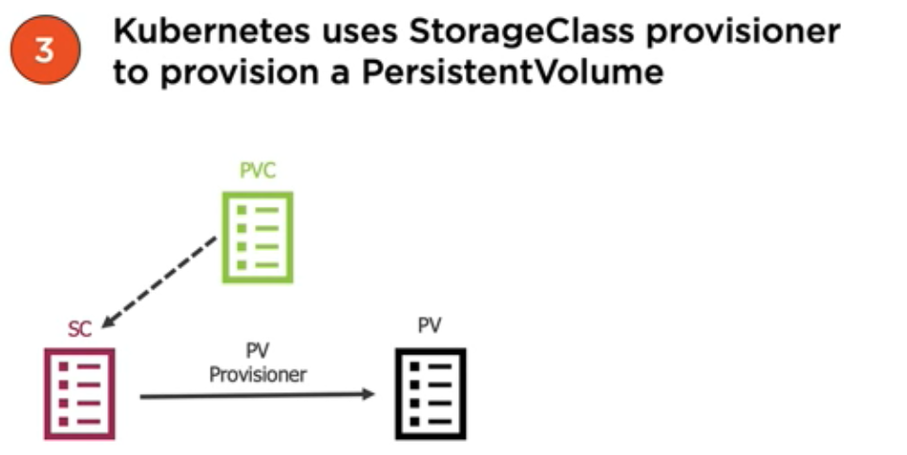

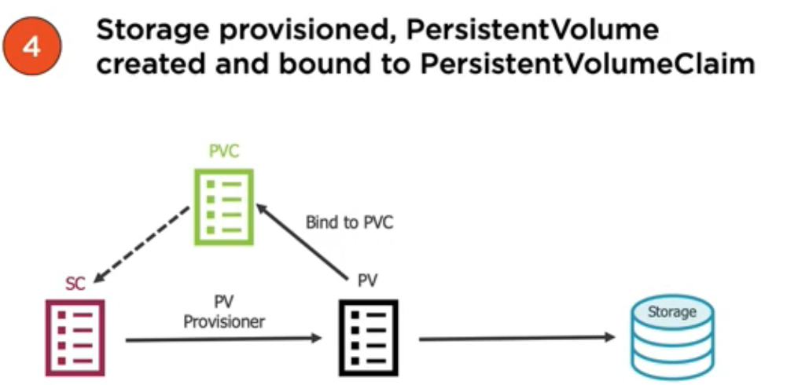

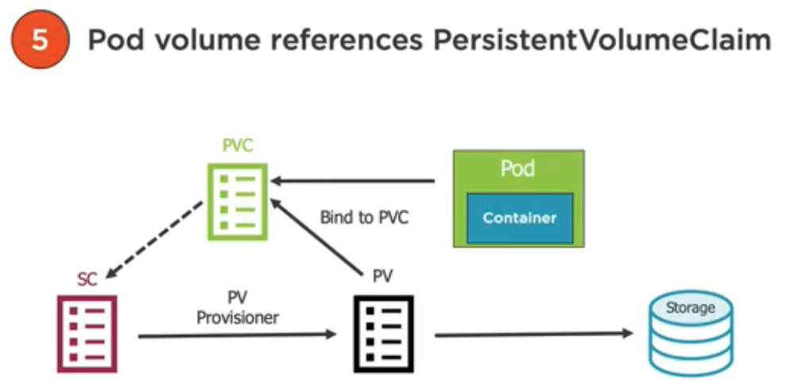

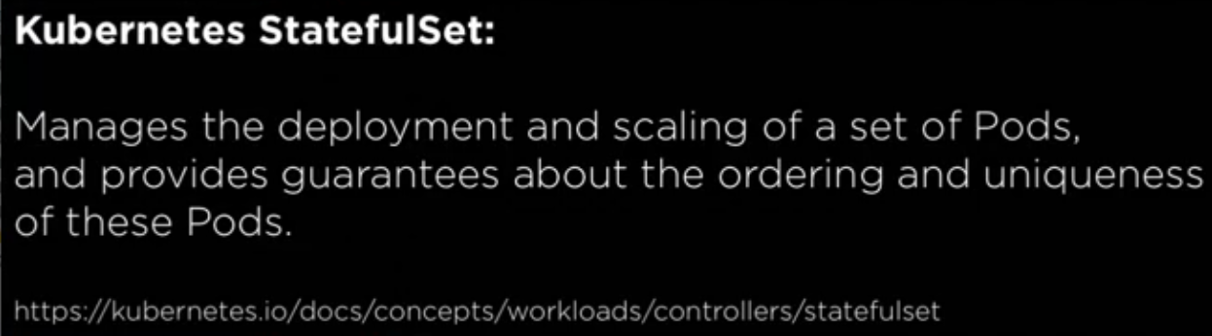



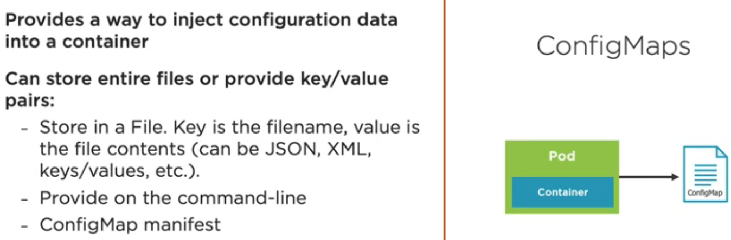

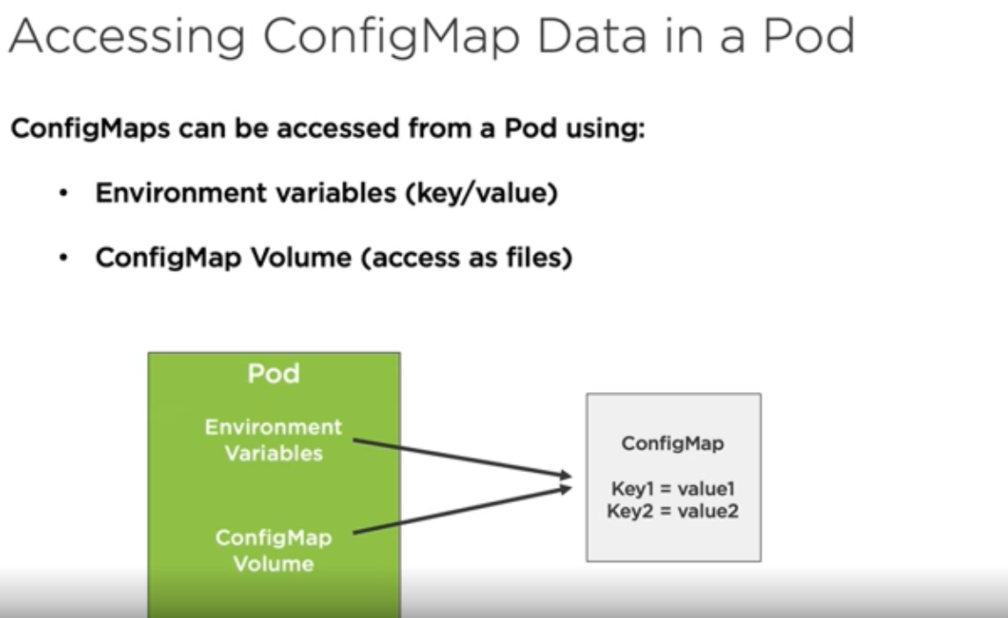

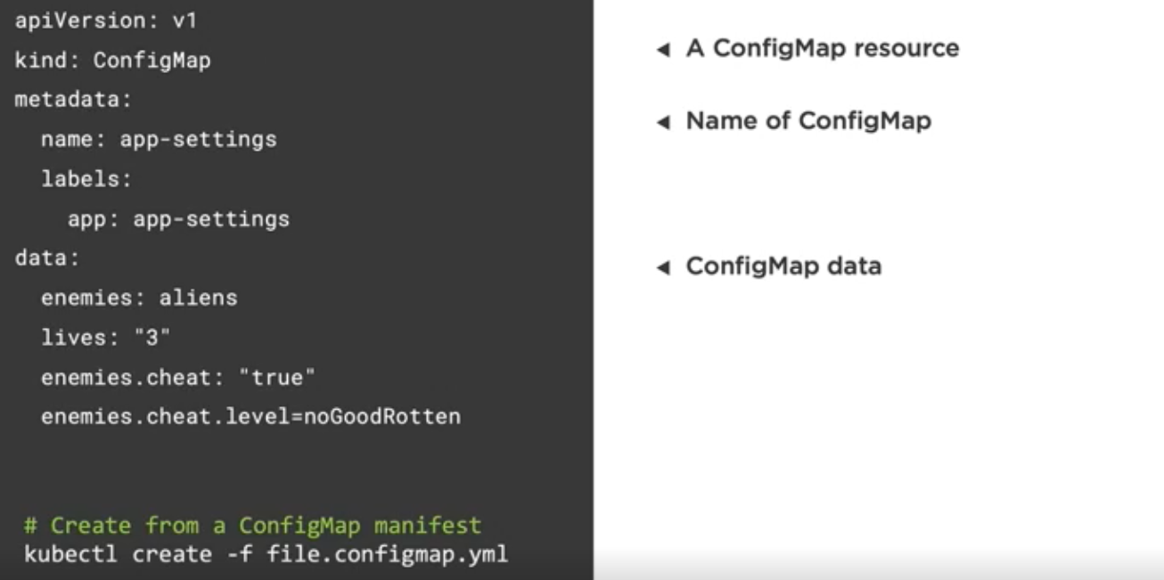

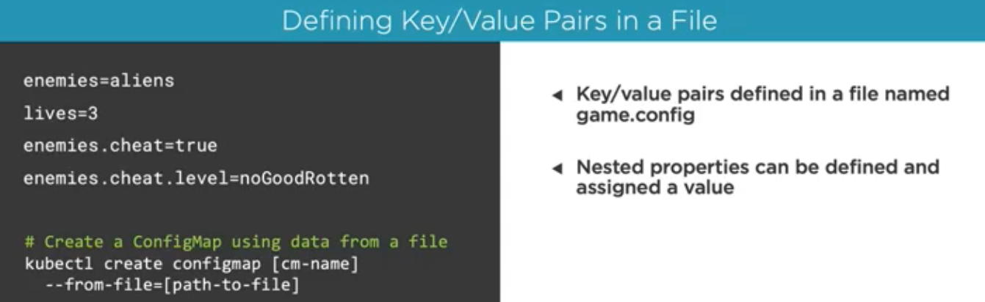

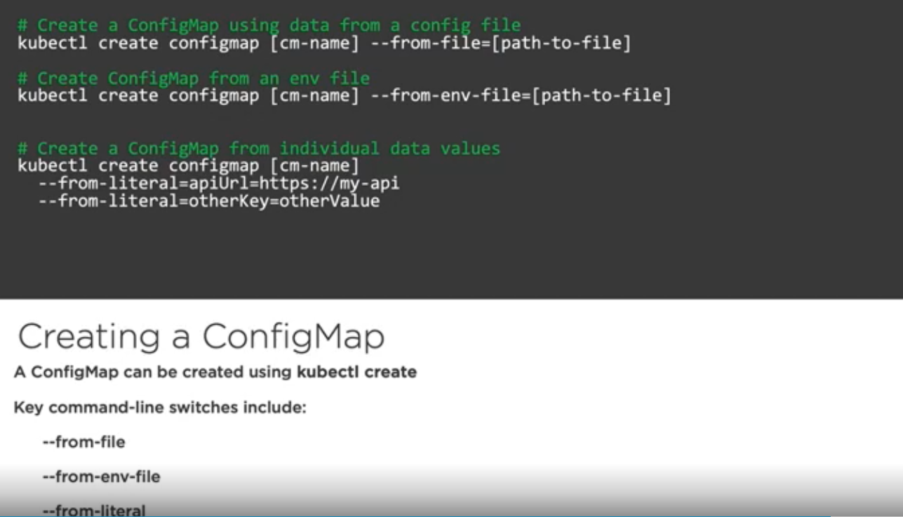

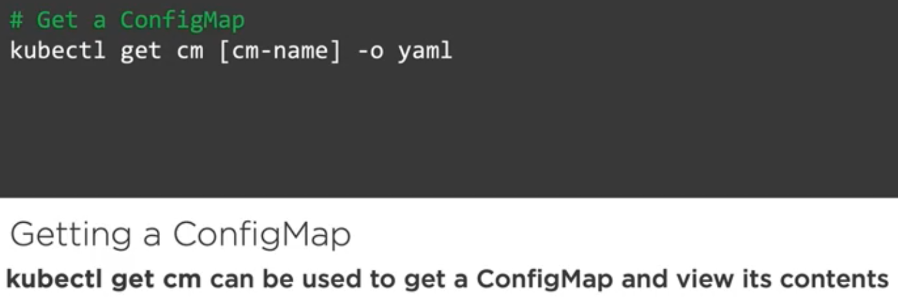

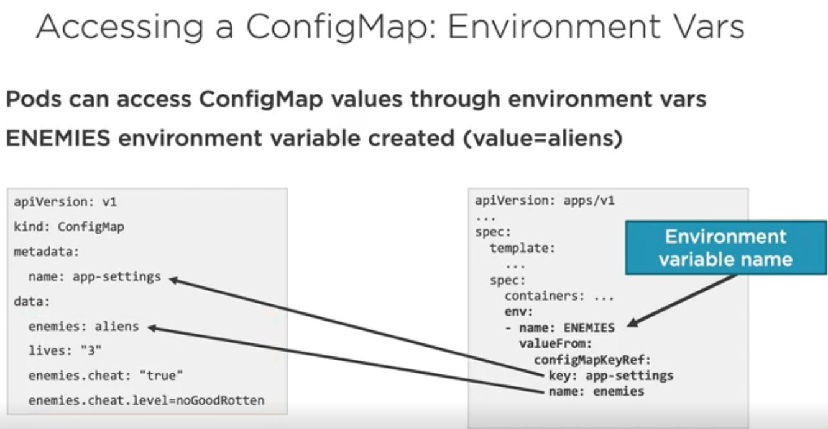



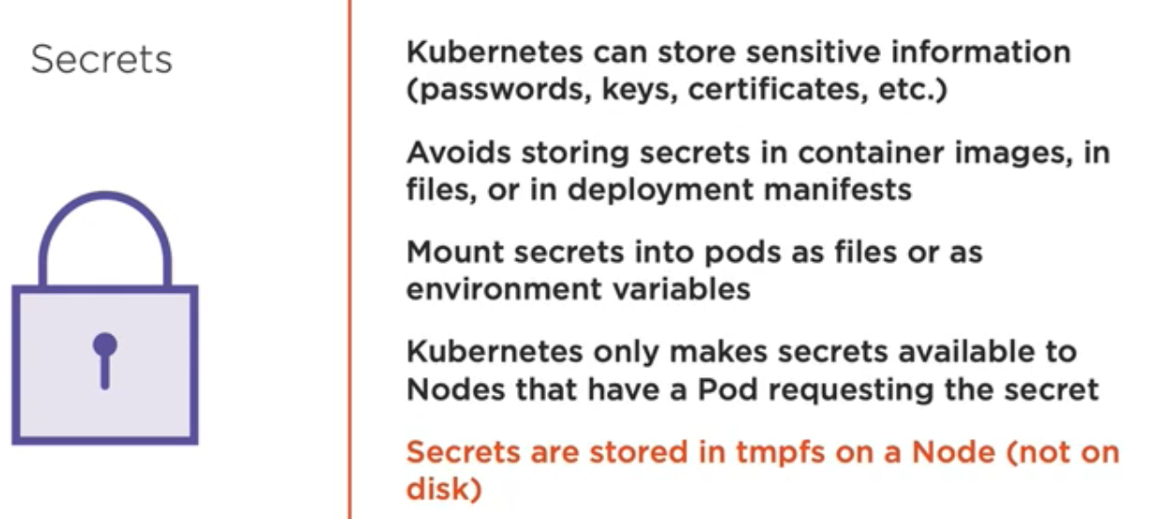

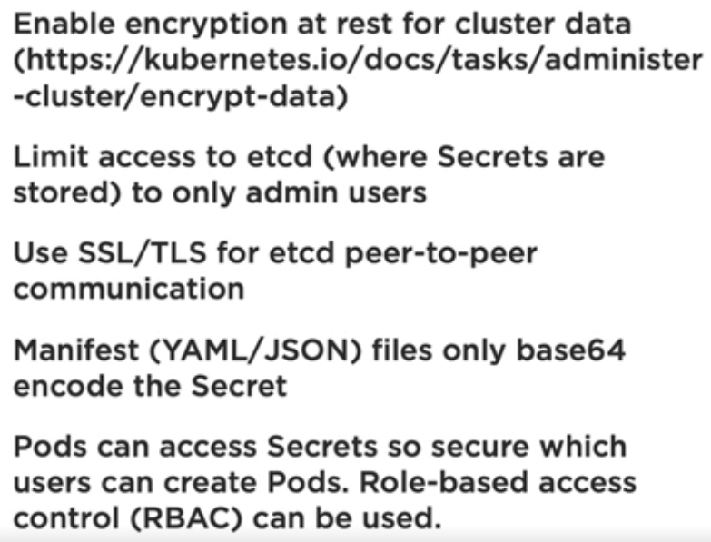

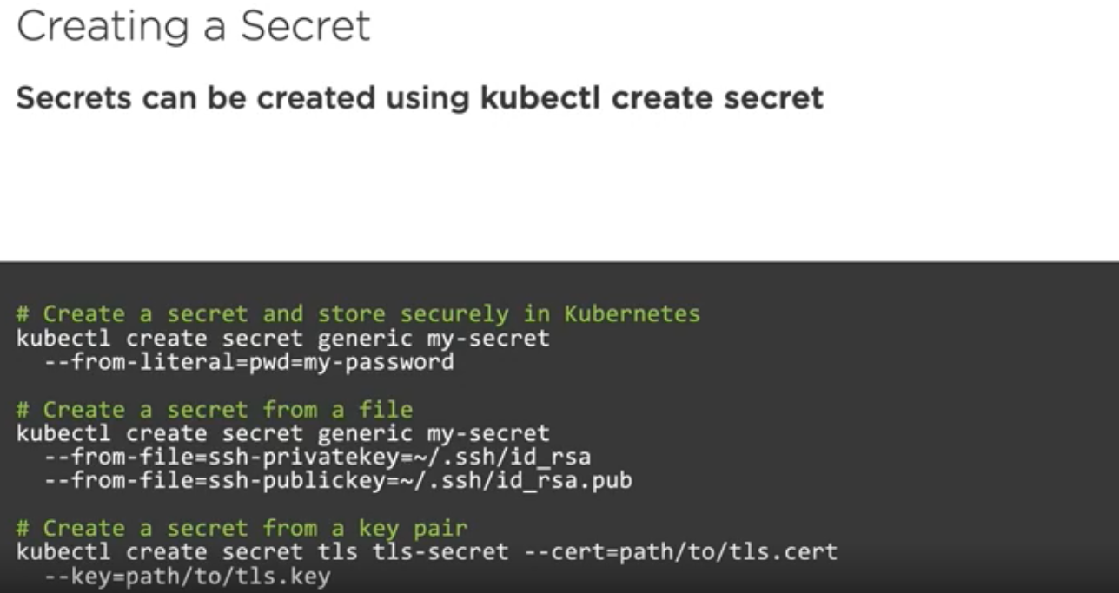

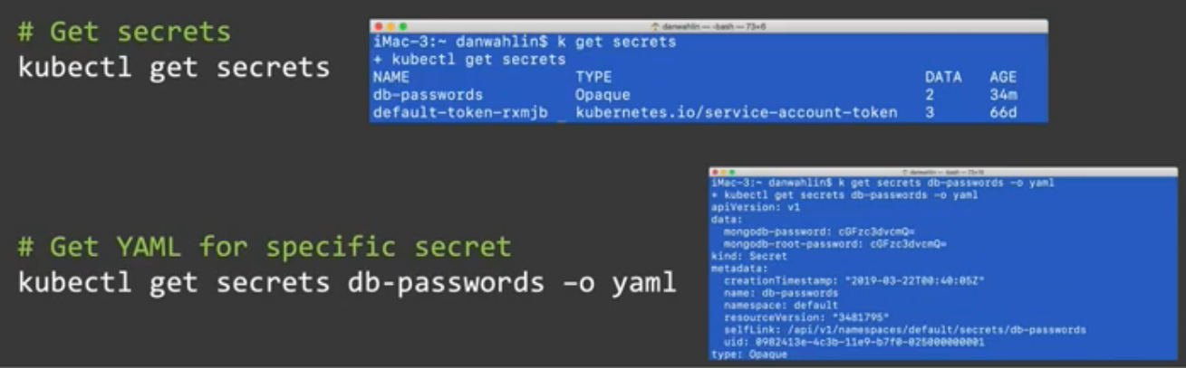

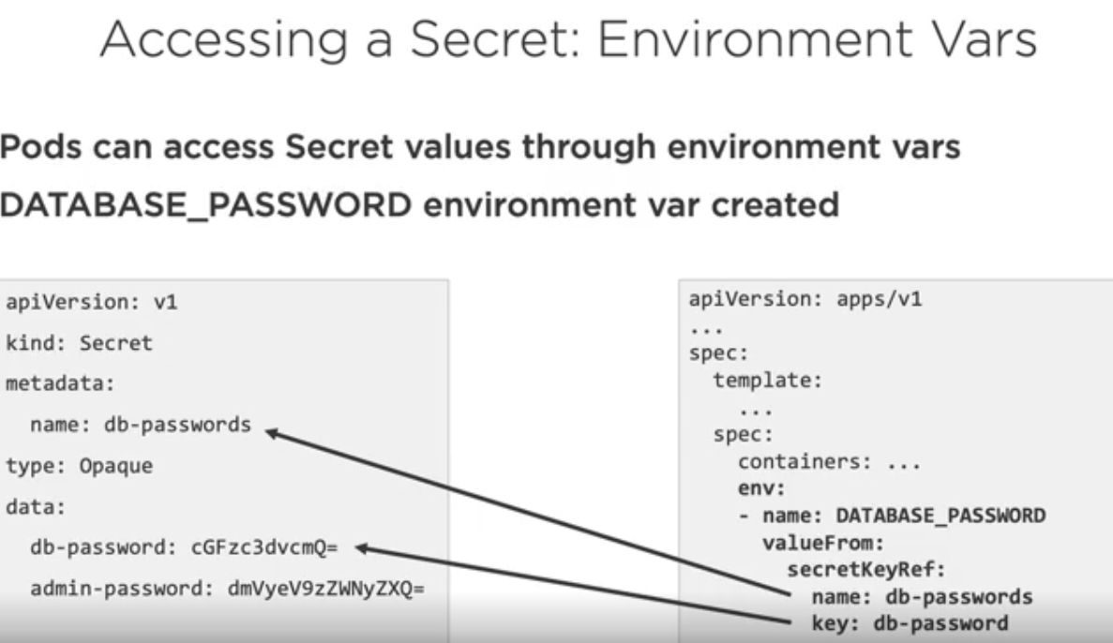

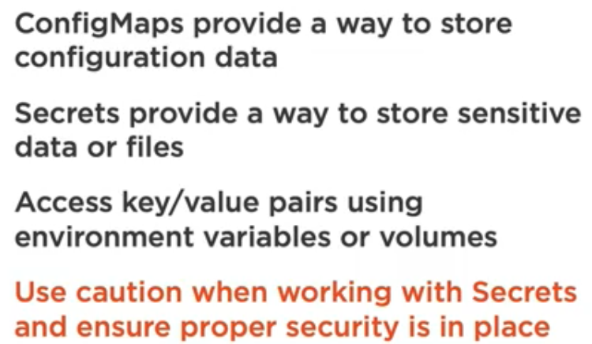

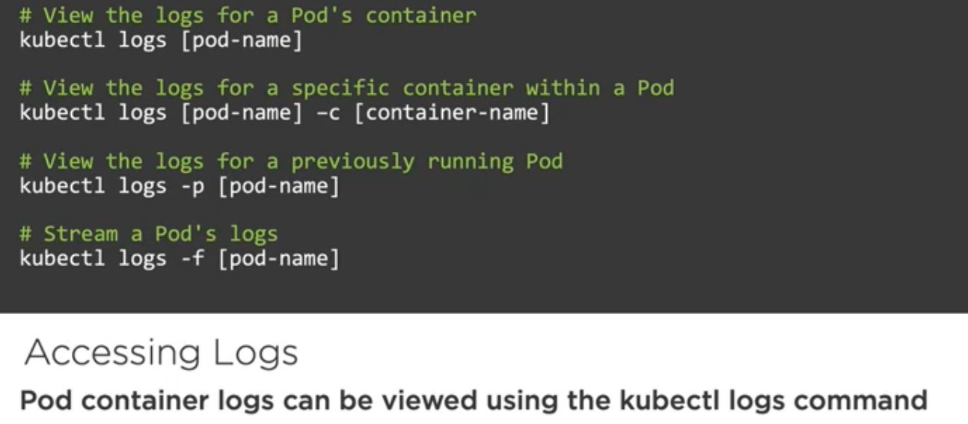

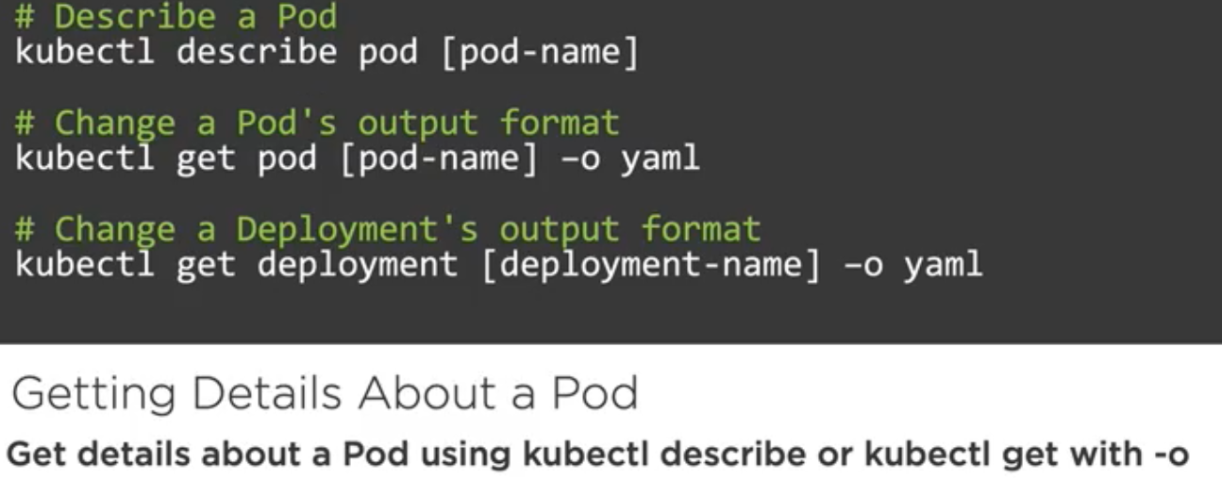

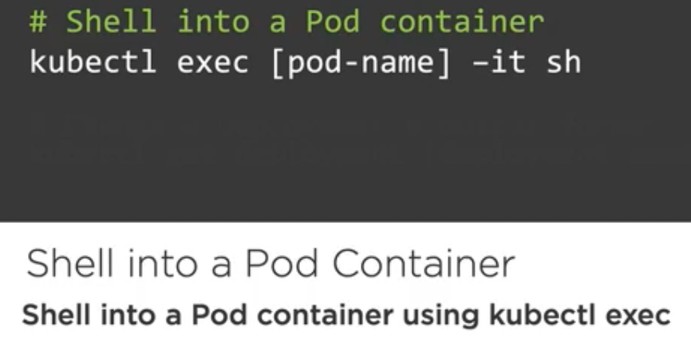

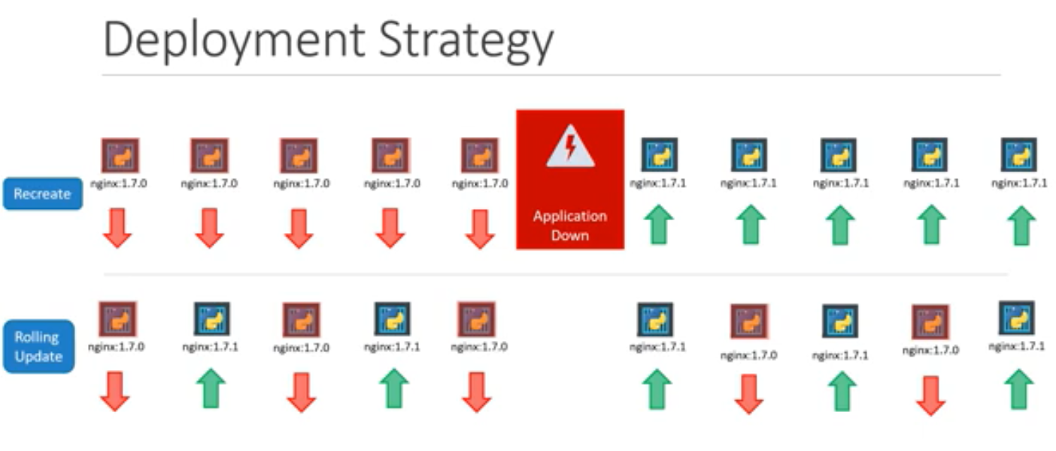

**Rolling Update is the default deployment strategy**

**To reset the image:**

Kubectl set image deployment/myapp-deployment \ nginx=nginx:1.9.1

**In case of Recreate strategy type in deployment all replica set scaled down to zero first followed by scaled up to required number of replica set**

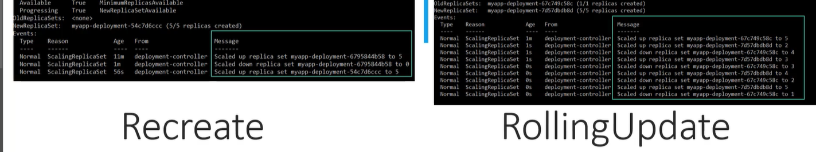

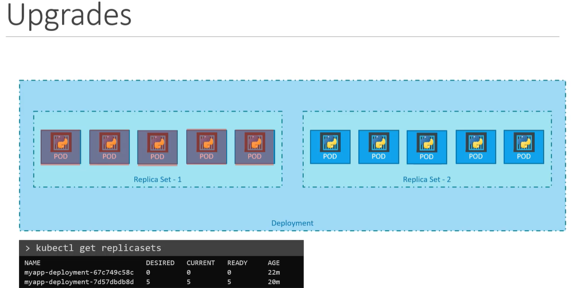

**Rolling back to previous edition:**

kubectl rollout undo deployment/<Name>

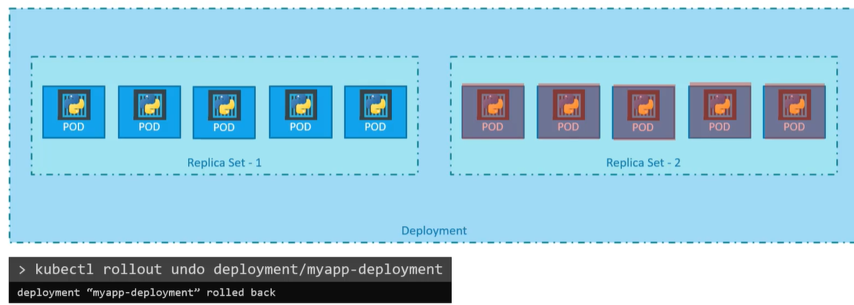

**To create a POD:**

kubectl run nginx –image=nginx

It also creates a deployment

**Rollout is the process of deploying the container in the backend:**

**Kubectl rollout status deployment/myapp-deployment**

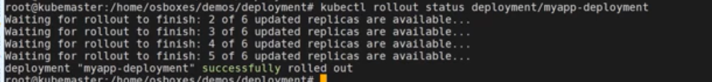

**To check the deployment revision:**

Kubectl rollout history deployment/myapp-deployment

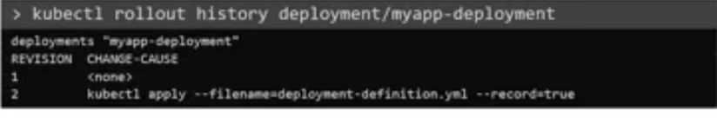

**Rollback to previous revision:**

kubectl rollout undo deployment/myapp-deployment

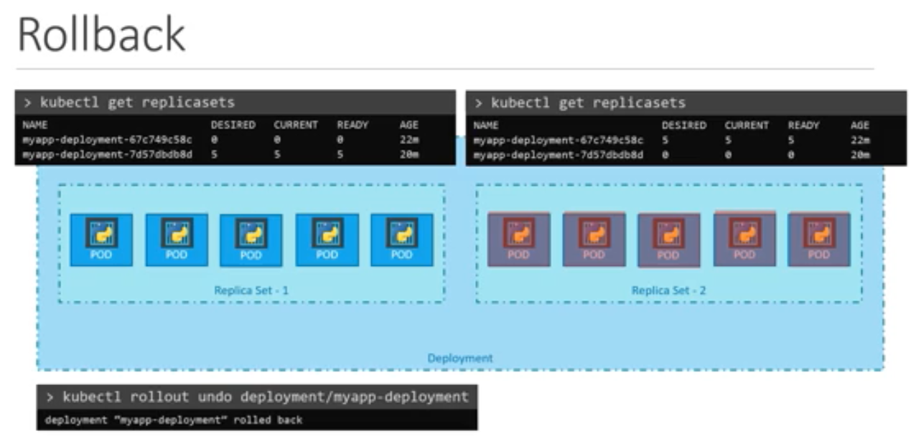

**22nd March 2020**

Namespace:

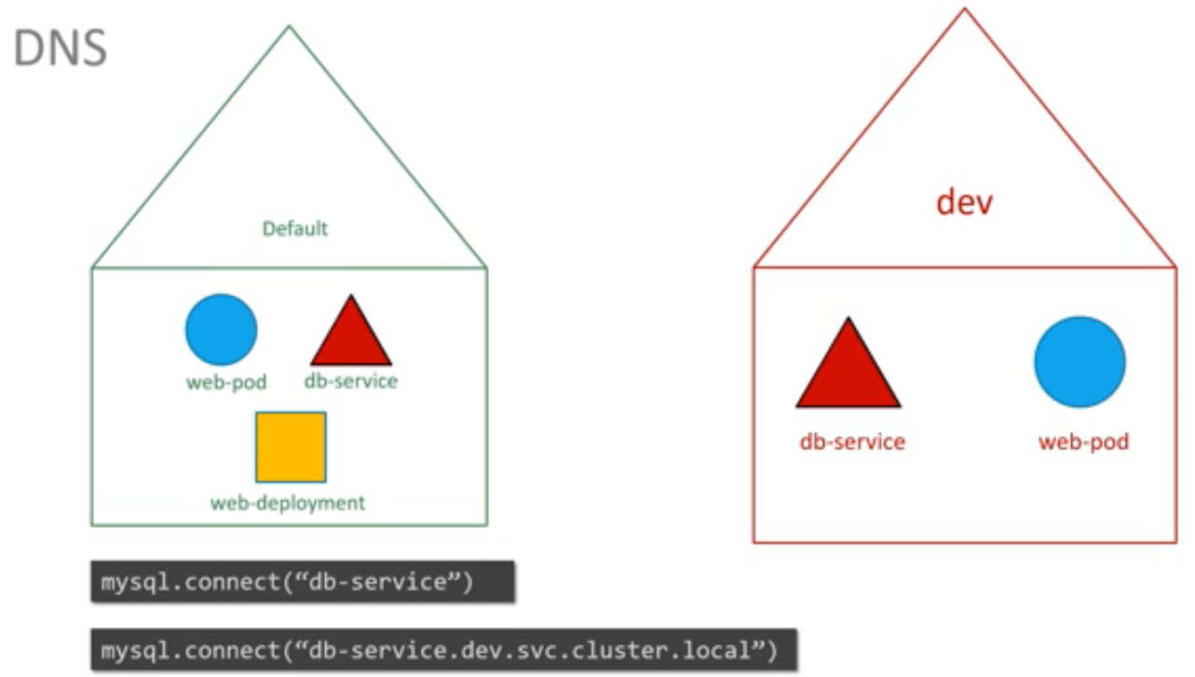

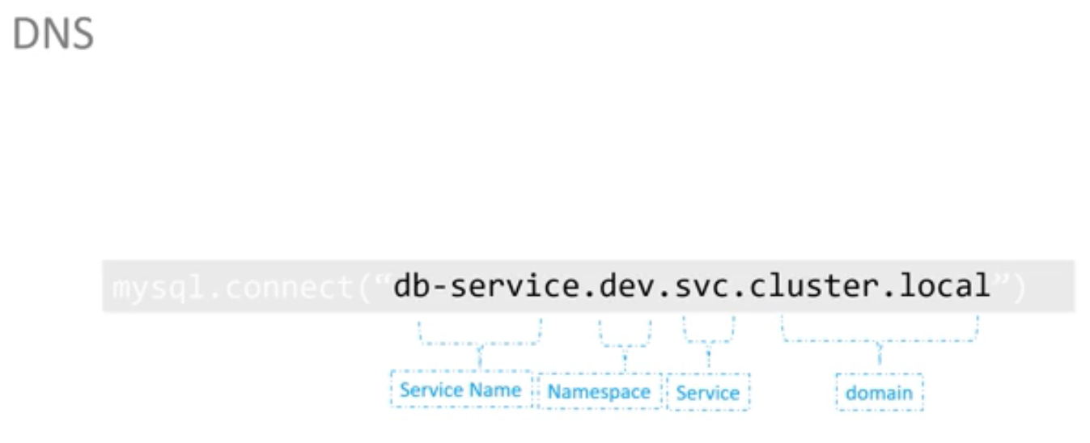

**Command to list pod of all name space or a particular namespace:**

kubectl get pods --namespace=kube-system

**To create a pod in a namespace:**

We can add namespace field in metadata section

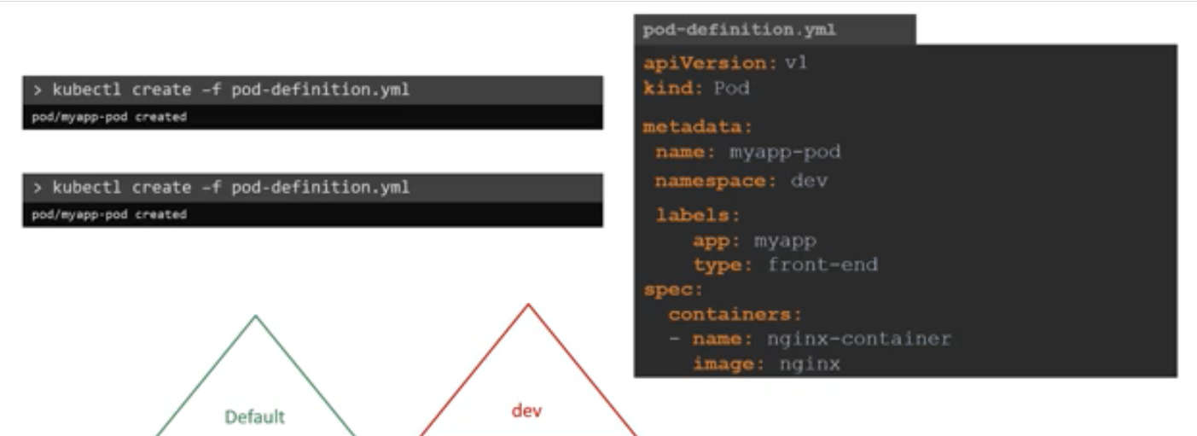

**How to create a namespace:**

🡪kubectl create namespace dev

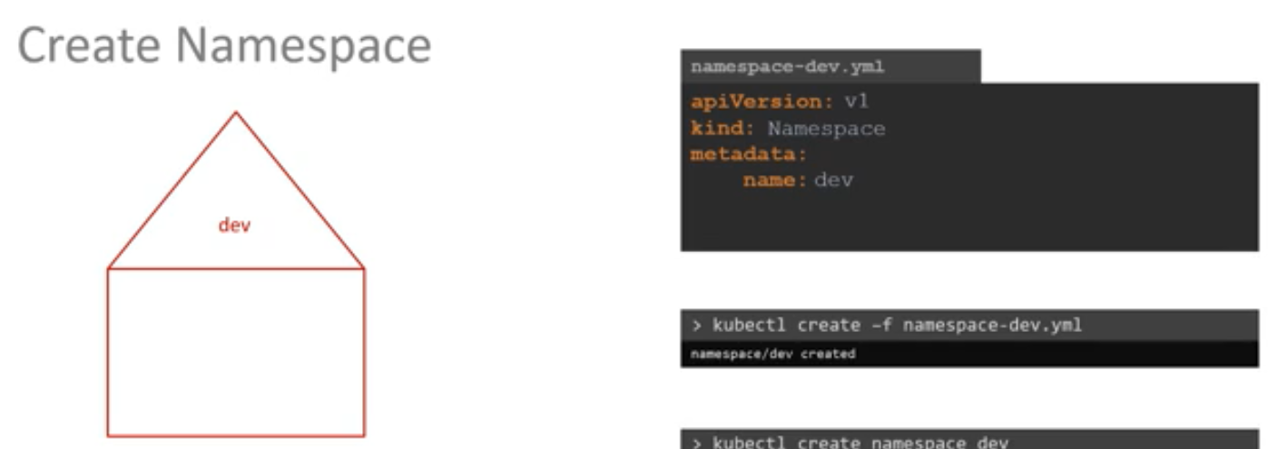

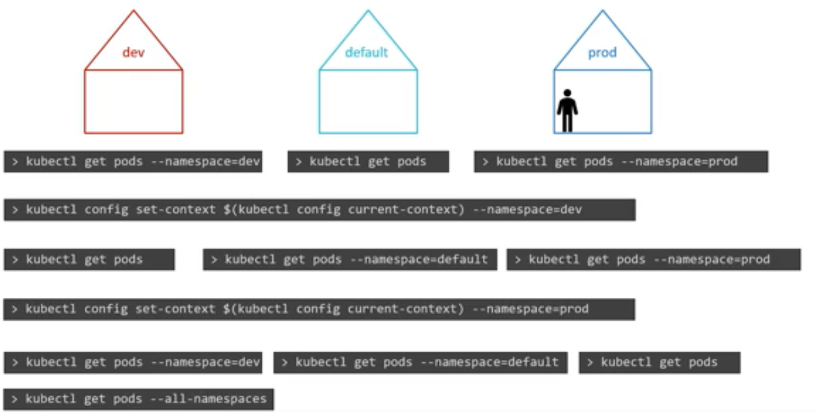

**To set namespace:**

kubectl config set-context $(kubectl config current-context) –namespace=prod

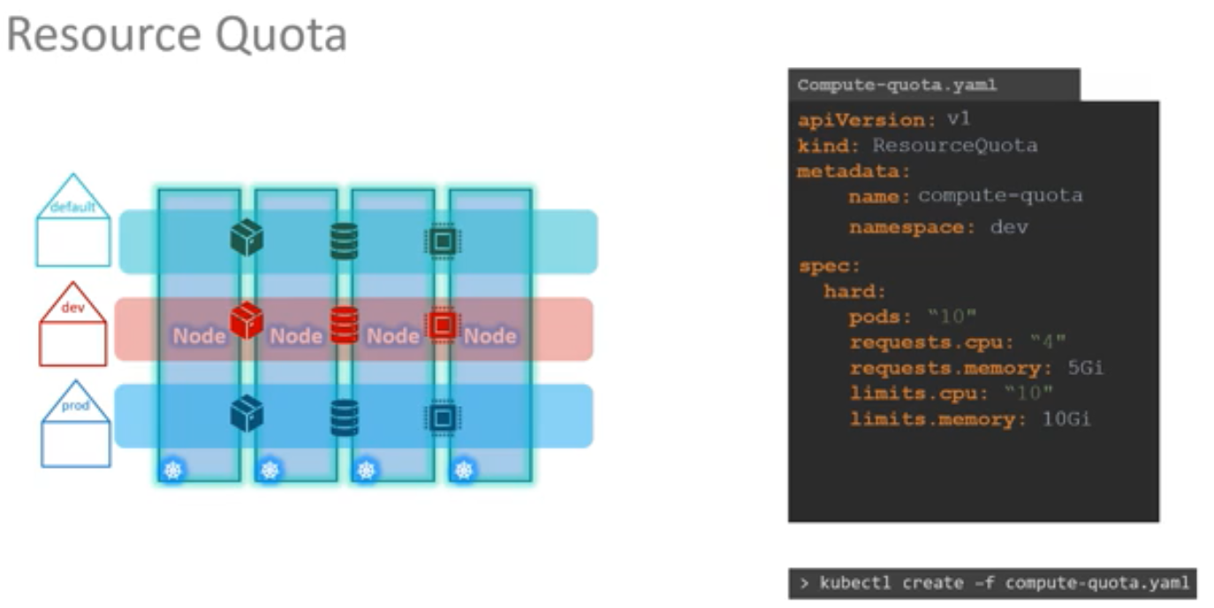

**To know about different name-spaces:**

kubectl get namespaces

**To list all the pod in a particular name spaces:**

kubectl get pods --namespace=research

**Create a Pod in a particular namespace:**

apiVersion: v1

kind: Pod

metadata:

name: redis

namespace: finance

labels:

app: redis

spec:

containers:

- name: redis

image: redis

**POD**

**Create a NGINX Pod**

kubectl run --generator=run-pod/v1 nginx --image=nginx

**Generate POD Manifest YAML file (-o yaml). Don't create it(--dry-run)**

kubectl run --generator=run-pod/v1 nginx --image=nginx --dry-run -o yaml

**Create a POD with label:**

kubectl run --generator=run-pod/v1 redis --image=redis:alpine -l tier=db

**Edit a pod:**

kubectl edit pod <pod name>

#### Deployment

**Create a deployment**

kubectl run --generator=deployment/v1beta1 nginx --image=nginx

Or the newer recommended way:

kubectl create deployment --image=nginx nginx

**To scale deployments**:

kubectl scale deployment/webapp --replicas=3

**Generate Deployment YAML file (-o yaml). Don't create it(--dry-run)**

kubectl run --generator=deployment/v1beta1 nginx --image=nginx --dry-run -o yaml

Or

kubectl create deployment --image=nginx nginx --dry-run -o yaml

**Generate Deployment YAML file (-o yaml). Don't create it(--dry-run) with 4 Replicas (--replicas=4)**

kubectl run --generator=deployment/v1beta1 nginx --image=nginx --dry-run --replicas=4 -o yaml

kubectl create deployment does not have a --replicas option. You could first create it and then scale it using the kubectl scale command.

**Save it to a file - (If you need to modify or add some other details)**

kubectl run --generator=deployment/v1beta1 nginx --image=nginx --dry-run --replicas=4 -o yaml > nginx-deployment.yaml

#### Service

**Create a Service named redis-service of type ClusterIP to expose pod redis on port 6379**

kubectl expose pod redis --port=6379 --name redis-service --dry-run -o yaml

(This will automatically use the pod's labels as selectors)

Or

kubectl create service clusterip redis --tcp=6379:6379 --dry-run -o yaml (This will not use the pods labels as selectors, instead it will assume selectors as **app=redis.**[You cannot pass in selectors as an option.](https://github.com/kubernetes/kubernetes/issues/46191)So it does not work very well if your pod has a different label set. So, generate the file and modify the selectors before creating the service)

**Create a Service named nginx of type NodePort to expose pod nginx's port 80 on port 30080 on the nodes:**

kubectl expose pod nginx --port=80 --name nginx-service --dry-run -o yaml

(This will automatically use the pod's labels as selectors, [but you cannot specify the node port](https://github.com/kubernetes/kubernetes/issues/25478). You have to generate a definition file and then add the node port in manually before creating the service with the pod.)

Or

kubectl create service nodeport nginx --tcp=80:80 --node-port=30080 --dry-run -o yaml

(This will not use the pods labels as selectors)

Both the above commands have their own challenges. While one of it cannot accept a selector the other cannot accept a node port. I would recommend going with the `kubectl expose` command. If you need to specify a node port, generate a definition file using the same command and manually input the nodeport before creating the service.

1. -o json Output a JSON formatted API object.
2. -o name Print only the resource name and nothing else.
3. -o wide Output in the plain-text format with any additional information.
4. -o yaml Output a YAML formatted API object

**Commands and arguments:**

Container only lives as long as the process inside it alive.

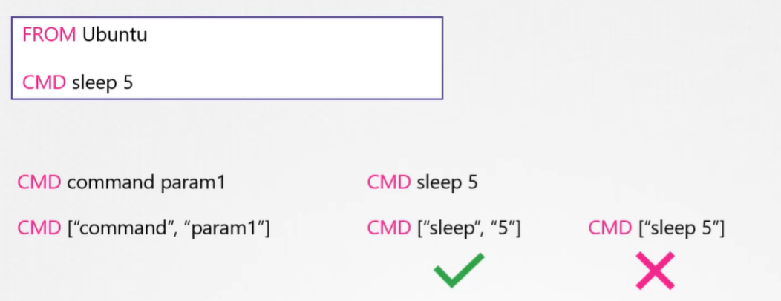

**Difference between Command and Entry-Point:**

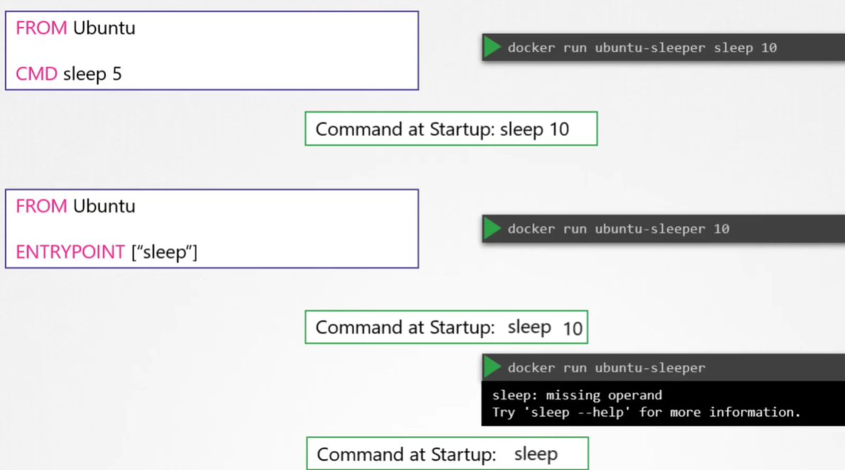

In case of CMD the command line parameter will replace. However, in case of Entrypoint the command line parameter gets appended.

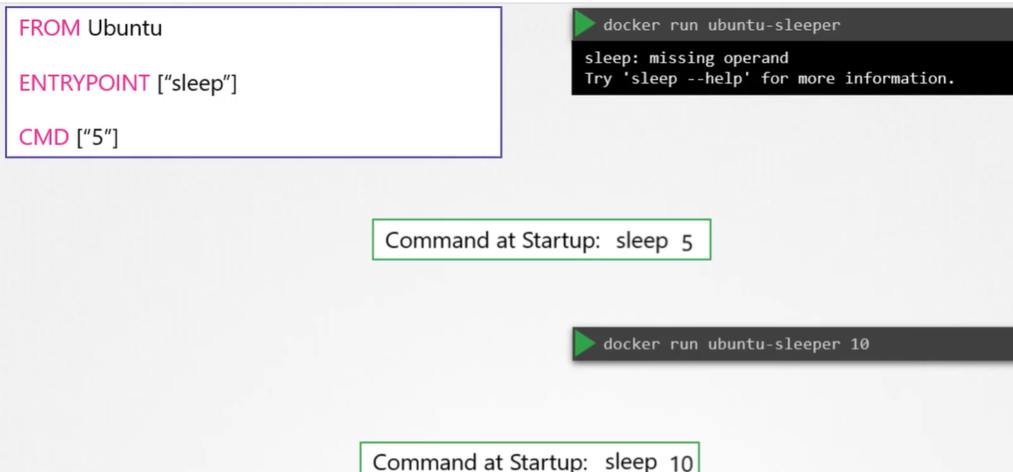

**Commands and arguments in kubernetes pod:**

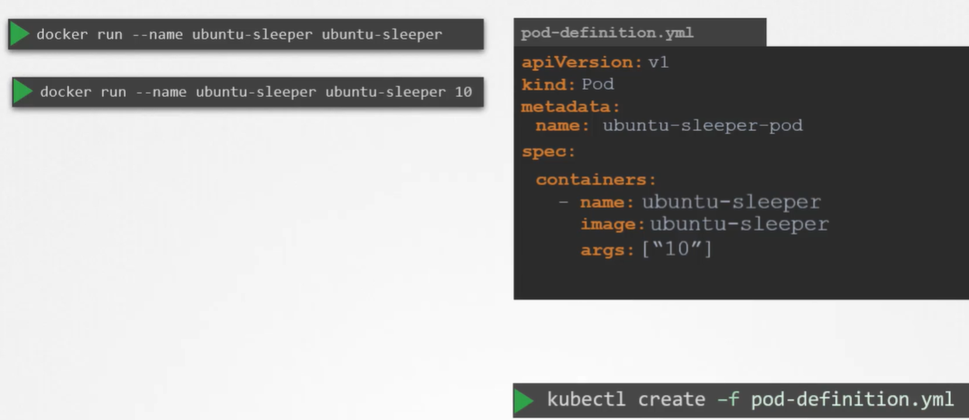

Command field correspond to entry-point in docker file.

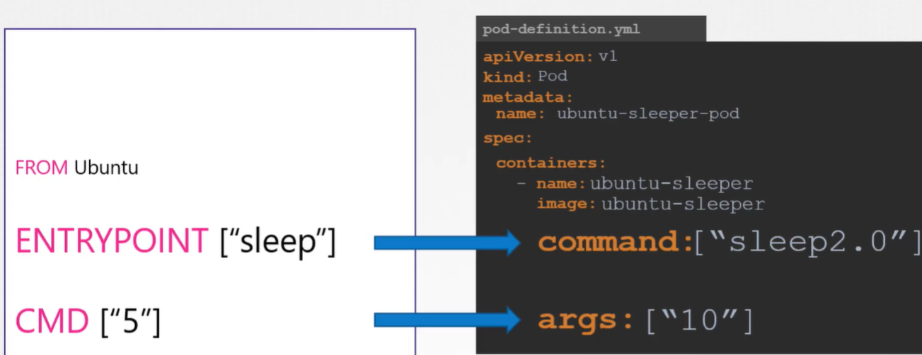

**Environment Variable in Kubernetes:**

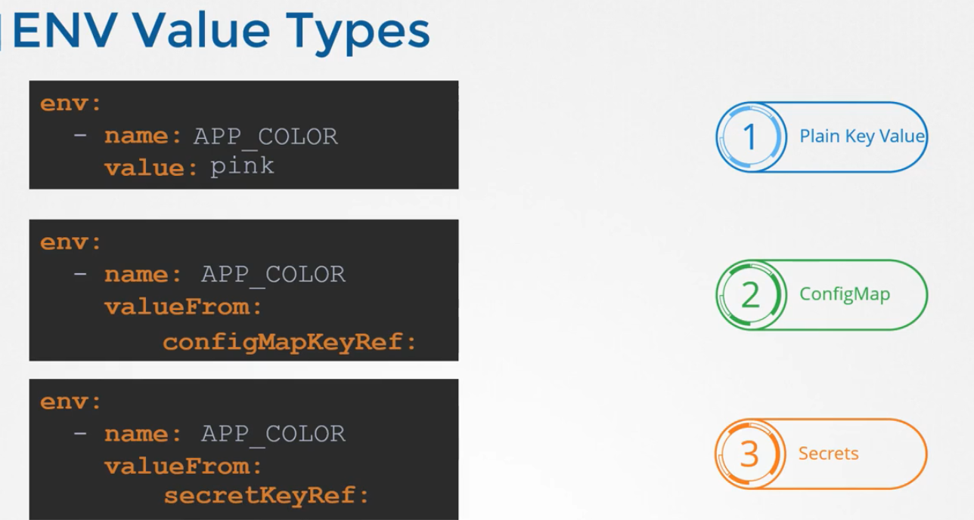

**ConfigMaps:**

It involves 2 steps. Create the config map and inject the value

